- E-commerce:
  - E-commerce, in the popular sense, can be defined as: the use of the Internet and the Web to conduct business transactions.
  - Buying and Selling over the Internet is called e-commerce
  - Digitally enabled commercial transactions between and among organizations and individuals
  - E-commerce technology is different, more powerful than previous technologies
Such as Radio commerce, Tv Commerce etc.
  - Traditional commerce:
    - Passive consumer->who did not participate but force by sales force to purchase products
    - Sales-force driven
    - Fixed prices
    - Information asymmetry
      - Information asymmetry refers to any disparity (gap) in relevant market information among the parties involved in a transaction. It generally applies to information about price, cost, and hidden fees.
- E-business:
  - Digital enablement of transactions and processes within a firm, involving information systems under firm’s control
  - Does not include commercial transactions involving an exchange of value across organizational boundaries.
  - Example: A business has online Inventory System. An Inventory goes from one department to another; there is no transaction in terms of exchange of value.
    - More formally we can say
    - A company’s online inventory control mechanisms are a component of e-business, but such internal processes do not directly generate revenue for the firm from outside businesses or consumers.
    - Its true, that a firm’s e-business infrastructure provides support for online e-commerce exchanges.
Difference b/w E-Commerce and E-Business
E-commerce differs from e-business in that no commercial transaction, an exchange of value across organizational or individual boundaries, takes place in e-business.
E-business is the digital enablement of transactions and processes within a firm and therefore does not include any exchange in value. E-commerce and e-business intersect at the business firm boundary at the point where internal business systems link up with suppliers. For instance, e-business turns into e-commerce when an exchange of value (money) occurs across firm boundaries.
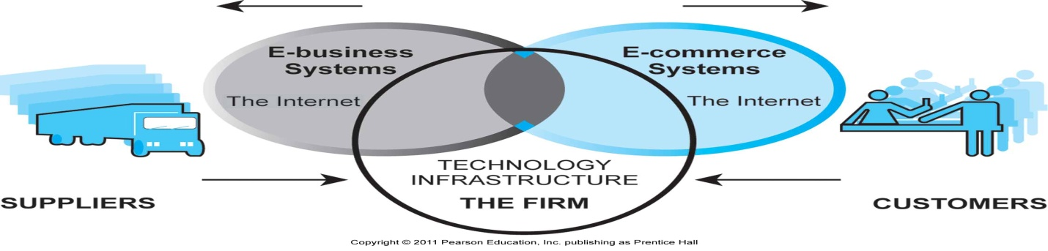
E-commerce primarily involves transactions that cross firm boundaries. E-Business primarily involves the application of digital technologies to business processes within firm.
Unique features of e-commerce technology
Eight unique features of e-commerce technology that make it superior than Traditional Business.

- UBIQUITY: It is available just about everywhere and at all times.
- In traditional commerce, a marketplace is physical place you visit in order to transact.
For example, television and radio typically motivate the consumer to go some place to make a purchase.
- E-commerce, in contrast, is characterized by its ubiquity.
- It liberates the market from being restricted to a physical space and makes it possible to shop from your Desktop Computer at home, at work, or even from your car using mobile commerce, the result is called a marketspace.
- A marketplace extended beyond traditional boundaries and removed from a temporal and geographic location is called marketspace.
- From a consumer point of view, ubiquity reduces
  - Transactions costs- the costs of participating in a market to transact, it is no longer necessary that you spend time and money traveling to a market.
  - At a broader level, the ubiquity of e-commerce lowers the cognitive energy required to transact in a marketspace.
  - Cognitive energy refers to the mental effort required to complete a task.
Humans generally seek to reduce cognitive energy. When given a choice, humans will choose the path requiring the least effort- the most convenient path.
Examples:
  - Accessing a bank account from your computer/laptop/mobile, transfer of money from one account to another.
  - Purchasing a Laptop from Hafeez Centre required more time and cognitive energy as compared to purchase from dell.com
  - Easypaisa
  - Paying Utility Bills from your Bank Account
  - Forex.com online money trading -> Buying and Selling in various types Dollar, Euro etc.

- GLOBAL REACH:
Reach: the number of user or customers an e-commerce business can obtain
  - E-commerce technology permits commercial transactions to cross cultural and national boundaries far more conveniently and cost-effectively than is true in traditional commerce.
As a result, the potential market size for e-commerce merchants is roughly equal to the size of the world’s online populations over 1.6 billion in 2009 and growing rapidly
  - The total number of users or customers an ecommerce business can obtain is a measure of its reach.
  - In contrast, most traditional commerce is local or regional – it involves local merchants or national merchants with local outlets.
  - Television and radio stations, and newspapers, for instance, are primarily local and regional institutions with limited but powerful national networks that can attract a national audience.
  - In contrast to e-commerce technology, these older commerce technologies do not easily cross national boundaries to a global audience.
Examples:
- Facebook users are more than 35 million in just less than 10 years.
- Alibaba.com, a China based web platform now have millions of customers / suppliers around the Globe.

- UNIVERSAL STANDARDS: Standards that are shared by all nations around the world

  - The technical standards of the Internet, and therefore of conducting e-commerce, are shared by all of the nations around the world.
  - Unique Feature of e-commerce technologies is that the technical standards of the internet, and therefore the technical standards for conducting e-commerce are universal standards – they are shared by all the nations around the world.
  - In contrast, most traditional commerce technologies differ from one nation to the next.
  - For instance, television and radio standards differ around the world, as doe’s cell telephone technology.

The benefits of universal standards are:
- Reduced search costs for consumers– the effort required to find suitable products.
- Becomes simpler, faster, with more accurate price discovery
- Lower market entry costs for merchants- the cost merchants must pay just to bring their goods to market.

With e-commerce technologies, it is possible for the first time in history to easily find many of the suppliers, prices, and delivery terms of a specific product anywhere in the world.

- RICHNESS: the complexity and content of a message
  - Information that is complex and contents are rich can be delivered without sacrificing reach.
  - Traditional markets, national sales forces, and small retail stores have great richness: they are able to provide personal, face-to-face service using aural and visual cues when making a sale.
  - The richness of traditional markets makes them a powerful selling or commercial environment.
  - Prior to the development of the Web, there was a trade-off between richness and reach: the larger the audience reached the less rich the message.
  - The internet has the potential for offering considerably more information richness than traditional media such as printing presses, radio, and television because it is interactive and can adjust the message to individual users.
  - Chatting with an online sales person, for instance, comes very close to the customer experience in a small retail shop.
  - The richness of the web allows retail and service merchants to market and sell ‘complex’ goods and services that heretofore really did require a face to face presentation by a sales force. Complex goods have multiple attributes, are typically expensive, and cannot be compared easily, such as used cars and even diamond rings.
Example:
As on certain event(Eid) a shopkeeper do not brief much about product feature due to excess customers lead to less Richness but in E-commerce always remain rich.

- INTERACTIVITY: E-commerce technologies allow two-way communication between the merchant and the consumer.
  - Unlike any of the commercial technologies of the 20th century, with the possible exception of the telephone, ecommerce technologies allow for interactivity, meaning they enable two-way communication between merchant and consumer.
  - Traditional television, for instance, cannot ask viewers any questions or enter into conversations with them, and it cannot request that customer information be entered into a form.
  - In contrast, all of these activities are possible on an ecommerce web site . interactivity allows an online merchants to engage a consumer in ways similar to a face-to-face experience, but on a much more massive, global scale.
Examples:
- Online chat between merchant and consumer
- Feed back
- Emails , Newsletter

- INFORMATION DENSITY: The total amount and quality of information available to all market participants’ consumers, and merchants alike.

- The internet and the web vastly increase information density.
- Ecommerce technologies reduce information collection, storage, processing, and communication costs.
- At the same time, these technologies increase greatly the accuracy and timeliness of information- making information more useful and important that ever.
- As a result, information becomes more plentiful, less expensive and of higher quality.

Growth in information density could result in:
- Greater price transparency: Consumers can easily find out the variety of prices in a market.
- Greater cost transparency: Consumers can discover the actual costs merchants pay for products.
- Greater opportunities for marketers to practice price discrimination: since marketers are able to gather much more information about their customers, they can segment the market into groups based on willingness to pay different prices for the same or nearly the same goods.
- Merchants also have enhanced abilities to differentiate their products in terms of cost, brand and quality.
Examples:
  - Go to Amazon store you can find verity of products and prices.
  - Segmentation:
Gold member, Silver member, Brown member on serversea.com
Office suite with some extra feature for premium customers

- PERSONALIZATION/CUSTOMIZATION:
  - Personalization: The targeting of marketing messages to specific individuals by adjusting the message to a person’s name, interest, and past purchases.
  - Customization: changing the delivered product or service based on a user’s preferences or prior behavior
  - E-commerce technologies enable merchants to target their marketing messages to a person’s name, interests, and past purchases. (Personalization)
  - This allows a merchant to change the product or service to suit the purchasing behavior and preferences of a consumer.
  - Given the interactive nature of ecommerce technology, much information about the consumer can be gathered in the marketplace at the moment of purchase. With the increase in information density, great deal of information about the consumer’s past purchases and behavior can be stored and used by online merchants.
  - But in tradition with existing commerce technologies for instance, you may be able to shape what you see on television by selecting a channel,
  - but you cannot change the contents of the channel you have chosen .
  - In contrast, the online version of the wall street journal allows you to select the type of news stories you want to see first, and gives you the opportunity to be alerted when certain events happen.
  - Personalization and customization allow firms to precisely identify market segments and adjust their messages accordingly.
Examples:
- Gmail Welcome Message (Personalization) Welcome: Name
- Change your Gmail background color scheme/ fonts (Customization)
- Customize a laptop on Dell.com (Customization)

- SOCIAL TECHNOLOGY:
  - User content generation and social networking technologies In a way quite different from all previous technologies,
  - The internet and ecommerce technologies have evolved to be much more social by allowing users to create and share content in the form of text, videos, music or photos with a worldwide community.
  - Using these forms of communication, users are able to create new social networks and strengthen existing ones.
  - All previous mass media in modern history, including the printing press, use a broadcast model 1 to M.
  - The telephone would appear to be an exception but it is not a mass communication technology. Instead the telephone is a one to one technology.
  - The new internet and commerce technologies have the potential to invert this standard media model by giving users the power to create and distribute content on a large scale.
  - The internet provides a many to many model of mass communication that is unique.
Examples:
facebook, youtube, myspace, buzz(a new social network by google) etc.
Blogs- Wordpress is most popular blogging tool to create a blog in minutes. http://www.wordpress.com

THE INTERNET AND WORLD WIDE WEB: E-COMMERCE INFRASTRUCTURE
A computer is a programmable machine that receives input, stores and manipulates data, and provides output in a useful format(information).
MEMORY : Enables a computer to store, at least temporarily, data and programs.
MASS STORAGE DEVICE : Allows a computer to permanently retain large amounts of data. Common mass storage devices include disk drives .
INPUT DEVICES : Usually a keyboard and mouse, the input device is the conduit through which data and instructions enter a computer.
OUTPUT DEVICES: A display screen, printer, or other device that lets you see what the computer has accomplished.
CENTRAL PROCESSING UNIT (CPU): The heart of the computer, this is the component that actually executes instructions.
PROTOCOLS : The rules and encoding specifications for sending data. The protocols also determine whether the network uses a peer-to-peer or client/server architecture.
MEDIA : Devices can be connected by twisted-pair wire, coaxial cables, or fiber optic cables. Some networks do without connecting media altogether, communicating instead via radio waves.

PERSONAL COMPUTER : A small, single-user computer based on a microprocessor. In addition to the microprocessor, a personal computer has a keyboard for entering data, a monitor for displaying information, and a storage device for saving data.
WORKSTATION : A powerful, single-user computer. A workstation is like a personal computer, but it has a more powerful microprocessor and a higher-quality monitor.
MINICOMPUTER : A multi-user computer capable of supporting from 10 to hundreds of users simultaneously.
MAINFRAME : A powerful multi-user computer capable of supporting many hundreds or thousands of users simultaneously.
SUPERCOMPUTER : An extremely fast computer that can perform hundreds of millions of instructions per second.

INTERNET
This is the world-wide network of computers accessible to anyone who knows their Internet Protocol (IP) address. The IP address is a unique set of numbers (such as 207.46.222.30) that defines the computer's location. Most will have accessed a computer using a name such as http://www.hailey.tech.officelive.com.
Before this named computer can be accessed, the name needs to be resolved (translated) into an IP address. To do this your browser (for example Netscape or Internet Explorer) will access a Domain Name Server (DNS) computer to lookup the name and return an IP address - or issue an error message to indicate that the name was not found.
Once your browser has the IP address it can access the remote computer. The actual server (the computer that serves up the web pages) does not reside behind a firewall - if it did, it would be an Extranet. It may implement security at a directory level so that access is via a username and password, but otherwise all the information is accessible.
WWW (World Wide Web)
It is a collection of interconnected documents and other resources, linked by hyperlinks and URLs. In short, the Web is an application running on the Internet.^{[18]} Viewing a web page on the World Wide Web normally begins either by typing the URL of the page into a web browser, or by following a hyperlink to that page or resource. The web browser then initiates a series of communication messages, behind the scenes, in order to fetch and display it.
The World Wide Web, abbreviated as WWW and commonly known as The Web, is a system of interlinked hypertext documents contained on the Internet. With a web browser(IE, Fire Fox etc), one can view web pages that may contain text, formatted text, images, videos, animations and other multimedia(audio files etc) and navigate between them(web pages) by using hyperlinks. Without the World Wide Web, there would be no e-commerce. The invention of the web brought an extraordinary expansion of digital services to millions of computer users.
In short, the web makes nearly all the rich elements of human expression needed to establish a commercial marketspace available to nontechnical computer users world wide.
A webpage or web page is a document or resource of information that is suitable for the World Wide Web and can be accessed through a web browser and displayed on a computer screen.
A web browser is a software application for retrieving, presenting, and traversing information resources on the World Wide Web. An information resource is identified by a Uniform Resource Identifier (URI) and may be a web page, image, video, or other piece of content. Hyperlinks present in resources enable users to easily navigate their browsers to related resources.
While the Internet was born in the 1960’s , The Web was invented in 1989 - 1991 when Dr Tim Berners-Lee and his associates at CERN Laboratories built on the ideas of several earlier authors and developed the initial versions of HTML, HTTP, a Web server, and a Web browser, the four essential components of the Web.
As long as each operating system had a IE browser, the same web pages could be used on all the different types of computes and operating systems, this meant the no matter what kind of computer you used, anywhere in the world, you would see the same web pages.
In 1994 Andreesen and Jim Clark founded Netscape, which created the first commercial browser. In 1995 Microsoft released the first version of Internet Explorer and the Web began to take off.

- HYPERTEXT
Web pages can be accessed through the Internet because the web browser software on your pc can request web pages stored on an internet host server using the http protocol.
Hypertext is a way of formatting pages with embedded links that connect documents to one another, and also link pages to other objects such as sound, video and information files. When you click on a graphic and a video clip plays, you have clicked on a hyperlink.
Hypertext makes possible a dynamic organization of information through links and connections (called hyperlinks).
For example, when you CLICK a hyper link on a web page in your browser such as (http://www.google.com ), your browser send an http request to the sec.gov server requesting the home page of google.
HTTP is the first set of letters at the start of every web address, followed by the domain name. The domain name specifies the organization’s server computer that is housing the document. Most companies have a domain name that is the same as or closely related to their official corporate name. The directory path and document name are two more pieces of information within the web address that help the browser track down the requested page. Together, the address is call a uniform resource locator, or URL. When typed into a browser, a URL tells it exactly where to look for the information.
For example, in the following URL: http://www.ebay.com/content/features/contactus.html
http = the protocol used to display web pages.
www.ebay.com = domain name
content/features = the directory path that identifies where on the domain web server the pages is stored
contactus.html = the document name and its format (an html page).
Common Domain Extensions:
Known as general top – level domains, or gTLDs officially sanctioned by ICANN such as
com(commercial use) , edu(for education), gov(government),mil(military), net(for network provider)
org(organization),tel (telephone numbers and other contact information) ,Countries also have domain names, such as .uk, .pk etc.
HTML(Hypertext Markup Language) -> HTML was designed to display data.
HTML (Hypertext Markup Language) is a relatively easy-to-use generalized markup language that provides a fixed set of markup "tags" that are used to format a Web page. It is used to set the style and page setup design for a document including designing text in a table format, positioning the tables, and different text formatting options.
HTML web pages can be created with any text editor, such notepad or wordpad , or any one of several web page development tools such as Frontpage, Dreamweaver, TinyHtml etc.
<html>
<body>
<h1>My First Heading</h1>
<p>My first paragraph</p>
</body>
</html>

WEB SERVERS
You already know that server is a computer attached to a network that stores files, controls peripheral devices, interfaces with the outside world – including the Internet – and does some processing for other computers on the network.
But what is Web Server? Web server software refers to the software that enables a computer(WebServer) to deliver web pages written in HTML (or any other language that is embed within HTML like Jsp, asp, php etc) to client computer on a network that request this service by send an HTTP request. Two leading brands of web server software are
- Apache which is free web server software -----------------50% of the market
- Microsoft’s Internet Information Services (IIS) ------------30% of the market
The term web server is sometimes also used to refer to the physical computer that runs web server software. Leading manufactures of web server computers include IBM, DELL etc.
Although any personal computer can run Web Server software (Apache or other), it is best to use a computer that has been optimized for this purpose.
To be a web server, a computer must have the web server software (Apache or other) described installed and be connected to the Internet.
Of course, firms also can use web serves for strictly internal local area networking in intranets.
Aside from responding to requests for web pages, all web servers provide some additional basic capabilities such as
SECURITY SERVICES
- Authentication – Verify that the person trying to access the site is authorized to do so.
- SSL (Secure Socket Layer) - For web sites that process payment transactions, the web server also support SSL, the Internet protocol for transmitting and receiving information securely over the Internet. When private information such as names, phone numbers, addresses, and credit card data needs to be provided to a web site, the web server uses SLL to ensure that the data passing back and forth from the browser to the server is not compromised.
FTP (File Transfer Protocol)
This Protocol allows users to transfer files to and from the server. Using some ftp program such File Zilla or simply typing ftp address of the site in Explorer(window explorer, IE, Firefox etc. ) i.e ftp://paperadspk.com
SEARCH ENGINE
Just as search engine sites enable users to search the entire web for particular documents. Web Server software enable indexing of the site’s web pages and content, and permit easy keyword searching of the sites content. The search term is compared to the index to indentify likely matches.
- WEB CLIENT
Any computing device attached to the internet that is capable of mapping http request and displaying html pages. The most common Client is a Windows or Macintosh computer. However, the fastest – growing category of the web clients are not computers at all, but cell phones and handheld PDAs.
In general, web clients can be any device – including a refrigerator, stove, home lighting system, or automobile instrument panel – capable of sending and receiving information from Web servers.
- WEB BROWSERS
Web browsers are software programs whose primary purpose is to display WebPages. Most browsers support HTTP Secure and offer quick and easy ways to delete the web cache, cookies, and browsing history. Some browser’s(like IE, FIRE FOX etc) also supports Private Browsing, pop – up blocking and tabbed browsing.
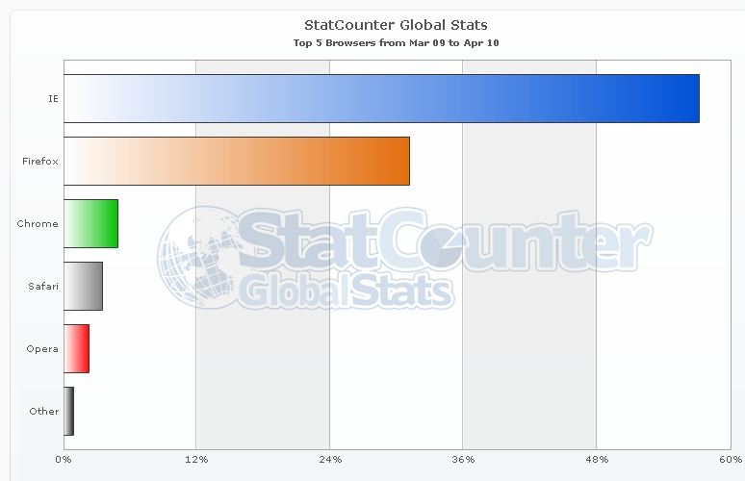

THE INTERNET AND THE WEB: FEATURES (How E-commerce possible - web services)
The Internet and the Web made e-commerce possible because they brought about an extraordinary expansion of digital services to millions of amateur computer users. The Web makes nearly all of the elements of rich human expression including color, text, images, photos, animations, sound, and video available, creating a unique environment in which to establish a commercial marketplace. Many of the Web's services and features support e-commerce, including.

- E-mail | - Search Engine | - Intelligent Agents (bots)
- Instant Messaging (IM) | - Online Forum & Chat | - Streaming Media
- Cookies | - Cookies

It is interesting as you read along to compare these services to other traditional media such as television, radio, telephone or print media (newspapers , magazine’s , letters etc). If you do, you will quickly realize how rich the Internet Environment is.

- E-mail or Electronic Mail:
Since its earliest days, electronic mail, or email, has been the most used application of the Internet. E-mail uses a series of protocols to enable messages containing text, images, sound, and video clips to be transferred from one Internet user to another. Because of its flexibility and speed, it is now the most popular form of business communication – more popular than the phone, fax or any postal services.
E-mail, for example, can be used as a very effective marketing tool. E-commerce sites can buy e-mail lists from various sources and collate(bring together) them with lists of their current customers to create a targeted advertising message that can be quickly and economically delivered and will produce a creditable response. Email messages include commercial, personal, spam and junk etc.
- Spam -- usually refers to advertising e-mails sent out randomly to generated e-mail addresses.
- Junk e-mails -- are usually sent from sites which have a record of your e-mail address either because you have signed onto(sites) them using your e-mail as your userid, or because you have ticked the appropriate box(check box) on the web-site allowing them to use your e-mail address in this way.
- Inbox-- contains new incoming emails.
- Sent-- A copy of messages you send are put into the Sent folder, if the Save to sent box is checked when you compose a message.
- Drafts-- A place for storing messages that you haven't finished writing. If you're in the middle of writing a message and need to stop for some reason, click the Save button to put it into the Drafts folder.
- Trash-- stores email that you have chosen to delete. When you delete email from a folder, it is put into the Trash folder. The messages are not truly deleted until you empty the folder.
- Attachment – a file (documents, images, sounds or video clip) inserted within an email message.

- Search Engine(user web crawlers or spiders also called bots, automated programs )
Identifies web pages that appears to match keywords, also called queries, typed by the user and provides a list of the best matches.
No one knows for sure how many web pages there really are. But obviously with so many web pages, finding web specific pages than can help you or your business, nearly instantly, is an important problem. The question is: how can you find the one or two web pages you really want and need out of the 50 billion indexed web pages?

Search engines (Google, Yahoo, Altavista, Msn windows live search, AOL, ask.com ) solve the problem of finding useful information on the web nearly instantly. There are hundreds of different search engines in the world, but the vast majority of the search results are supplied by the top fine providers.
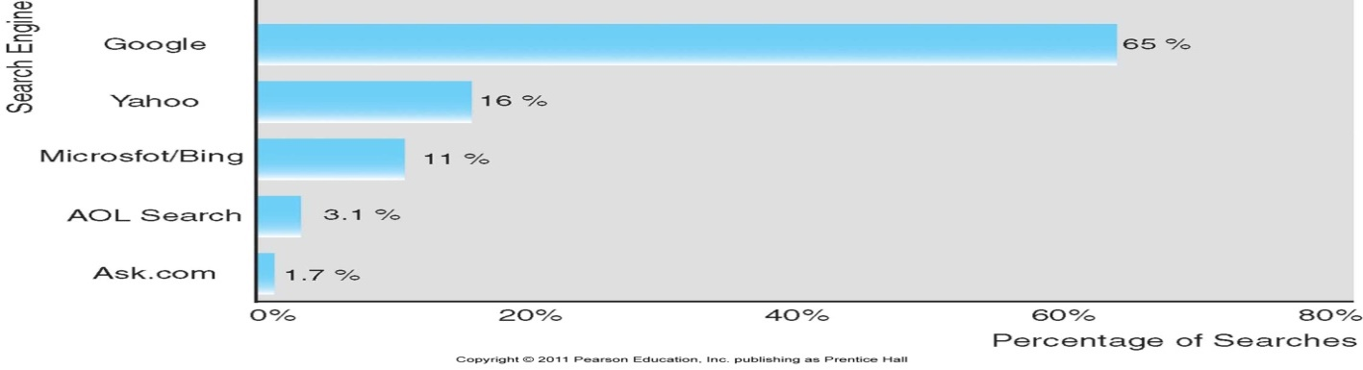
Google currently searches about more than 50 billion web pages and stores information about those pages in its massive computer network located throughout the United States.

How it works:
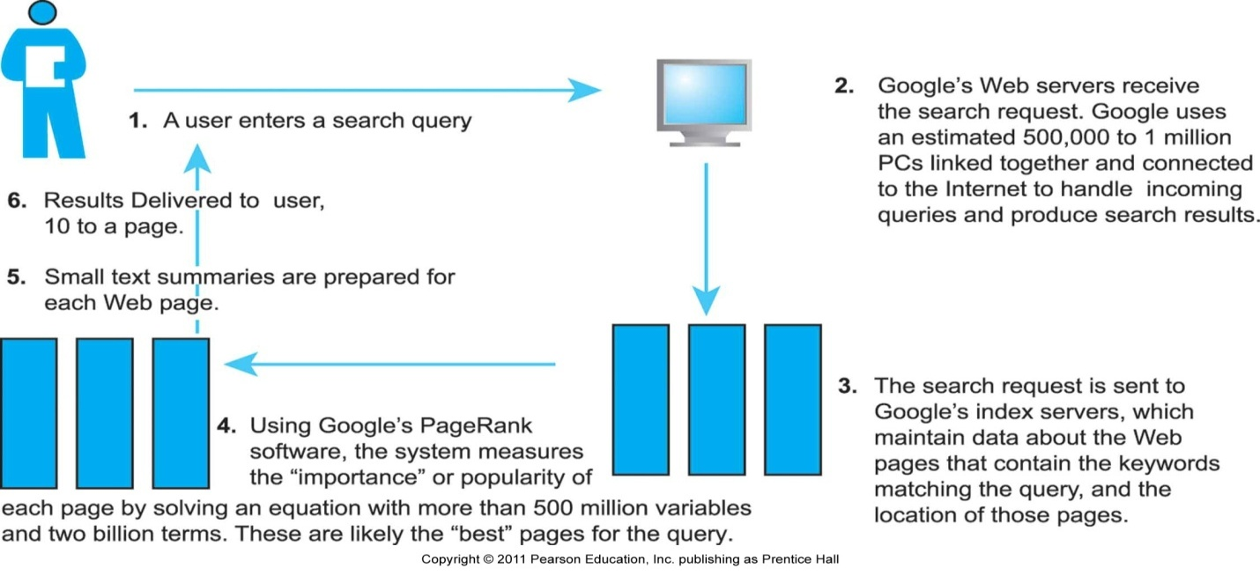

Altavista.com, one of the firs widely used search engines, was the first to allow “natural language queries such as “where is Pakistan” rather than “where + is + Pakistan”.

Search Engine Marketing:
Initially, few understood how to make money out of search engines, that changed in 2000 when GOto.com (Later overtrue.com) allowed advertisers to bid for placement on their search engine results, and Google followed suit in 2003 with its Ad Words program which allowed advertisers to bid for placement of short text ads on Google search results. The spectacular increase in Internet advertising revenues has helped search engines transform them selves into major shopping tools and created an entire new industry called “search engine marketing.” Search engine marketing has been the fastest – growing form of advertising in the US.

When users enter a search term at Google, MSN Search, Yahoo, or any of the other web sites serviced by these search engines, they receive two types of listing: sponsored links, for which advertises have paid to be listed (usually at the top of the search results page) and unsponsored “organic” search results. In addition, advertisers can purchase small text ads on the right side of the search results page.
In addition, search engines are extending their services to include maps, satellite images, computer images, email, calendars and group meeting tools. Outside of email, search engines are the most common onlIne daily activity and produce the largest online audiences.
Search engines (Site Own Search) have also become a crucial tool on e-commerce sites, providing a method for customers to quickly locate the product category or a specific product they are looking for.

- INTELLIGENT AGENTS (BOTS)

Software programs that gathers and/or filters information on a specific topic and then provides a list of results for the user ranked in a number of ways, such as from lowest price to availability or to delivery terms. Intelligent agents were originally invented by computer scientists interested in the development of artificial intelligence (a family of related technologies that attempt to imbue computers with human – like intelligence).
Many different types of intelligent agents or software robots are being used on e-commerce sites. For example, search bots are used to gather and filter information on Altavista.com; shopping bots such as MySimon.com search online retail sites and provide a list of the availability(in inventory or not) and pricing for products. For instance, you can use MySimon’s.com shopping bot to search for a Sony digital camera. The bot provides a list of online retailers that carry a particular camera model, as well as report about whether it is in inventory and the price and shipping charges.

Another type of bot, called a web monitoring bot, allows you to monitor for updated material on the web, and will e-mail you when a selected site has new or changed information.
News Bots will create custom newspapers or clip articles for you in newspapers around the world. Rss(Really simple syndication), is also a kind of automated program that send updates and news to subscribers, and is quickly becoming the most common type of web content monitoring tool.
ChatterBots: INTELLIGENT AGENTS (COMPTUER PROGRAMS) that could converse with a customer over the telephone or the web either in text or voice modes. Some time called remote agents. Chatterbots were programmed to both recognize human speech and to respond with meaningful suggestions or questions. If you call a large bank, credit card provider, or your cell service provider, chances are good you will be encouraged to talk with a chatterbot. They are on duty 24/7, cost very little to operate and can answer many questions of consumers using natural language. Millions of transactions in the United States and Europe are handled by chatterbots every day.

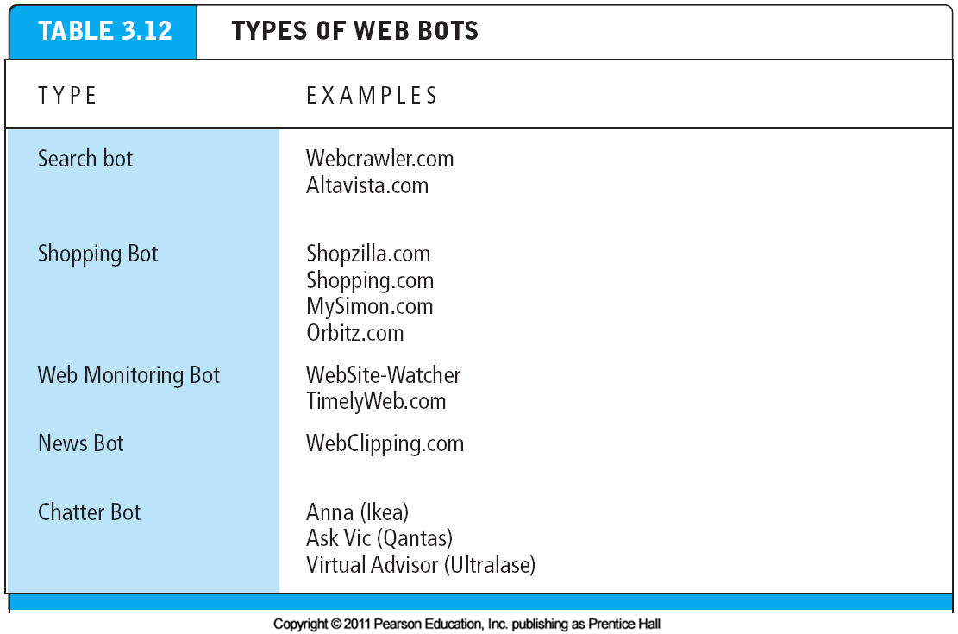

- Instant Messaging (IM):
One of the fastest growing forms of online human communication is instant messaging (IM). IM send text messages in real time, one line at a time, unlike e-mail. E-mail messages have a time lag of several seconds to minutes between when messages are sent and received. IM displays lines of text entered on a computer almost instantaneously. Recipients can then respond immediately to the send the same way, making the communication more like a live conversation.
To use IM, users identify a buddy list they want to communicate with, and then enter short text messages that their buddies will receive instantly (if they are online at the time). And although text remains the primary communication mechanism in IM, users can insert audio clips or photos into their instant messages, and even participate in video conferencing. Can also share files.
The IM systems are AOL, YAHOO, GOOGLE TALK, SKYPE, MSN etc. Ebuddy.com even you are not installed major IM like (msn, yahoo, etc on your computer).
Instant messaging has been added to some e-commerce Web sites as a method of accessing customer support personnel.

- Online Forum & Chat:
An online forum ( also referred to as a message board, bulletin board, discussion board, discussion group, or simply a board or forum) is a web application that enables internet users to communicate with each other, although not in real time. A forum provides a container for various discussions ( or “threads”) started (or posted) by members of the forum and depending on the permissions granted to forum members by the forum’s administrator, enables a person to start a thread and reply to other people’s threads. Most forum software allows more than one forum to be created. The forum administrator typically can edit, delet, move, or other wise modify any thread on the forum. In forum, member visit the forum to check for new posts Some forums offer an “e-mail notification” feature that notifies users that a new post of interest to them has been made.

An online Chat(text, audio, video) is a common feature of many Web sites, particularly those that focus on building a community of like-minded users. EXAMPLE: Typically users log in to a “chat room” where they can communicate in real time. Forum & Chat enables a group of Web site visitors to bond and network and keeps visitors coming back to a site.

- Streaming Media:
Streaming media enables live web video, music, video, and other large bandwidth files to be sent to users in a variety of ways that enable the user to play back the files.
Although the low bandwidth available during the early days of e-commerce limited the use of audio and video files, today video clips, Flash animations, and photographs are now fairly common on Web sites. Companies use these tools to demonstrate the use of their products, display product features, or simply to create interesting and eye-catching sites to which visitors will return. Audio marketing materials, customer reports, and discussions are also often used on Web sites as e-commerce tools. Streaming video ads are also becoming more commonplace. Sites such as Youtube, MetaCafe, and Google Video have popularized user – generated video streaming. Web advertisers increasingly use video to attract viewers. Streaming audio and video segments used in web ads and news stories are perhaps the most frequently used streaming services. As the capacity of the Internet grows streaming media will play an even larger role in e-commerce.

- Cookies:
Cookies are a very important tool (technique) used by marketers to collect and store information about a user. These small text files are sent to the user's computer so that information from the site will load more quickly the next time they visit. The cookie can contain any information desired by the site designers. More importantly from the e-tailer's perspective, cookies can retain information about the customer such as the number of pages visited, products examined, and other detailed information about a customer's behavior. Cookies enable sites to recognize returning visitors and target specific customers with special offers and marketing messages. Cookies also can pose a threat to consumer privacy, and at times they are bothersome. Many people clear their cookies at the end of every day. Some disable them entirely using tools built into most browsers but maybe site did not opened correctly. Now browsers offer for example “start private browsing “ in Mozilla and Inprivate browsing in IE 8. Always open your site inprivate browsing mode when you are using Internet, to protect your privacy (bank account, debit card numbers etc).

